Answers to questions in

Lab 3: Image segmentation

Name: Markus Brislöv________________________________ Program: AUSY______________________

**Instructions**: Complete the lab according to the instructions in the notes and respond to the questions stated below. Keep the answers short and focus on what is essential. Illustrate with figures only when explicitly requested.

Good luck!

___________________________________________________________________________

**Question 1**: How did you initialize the clustering process and why do you believe this was a good method of doing it?

Answers:

*k*-means++ was used for initialization

it’s used to space the initial centroids

*k*-means is sensitive to initial centroids

picking initial centroids at random can yield a bad result

convergences to a suboptimal local minimum (minima for the distances)

results with *k-*means++ (K = 8, L = 10, seed = 14, scale_factor = 1, image_sigma = 1):



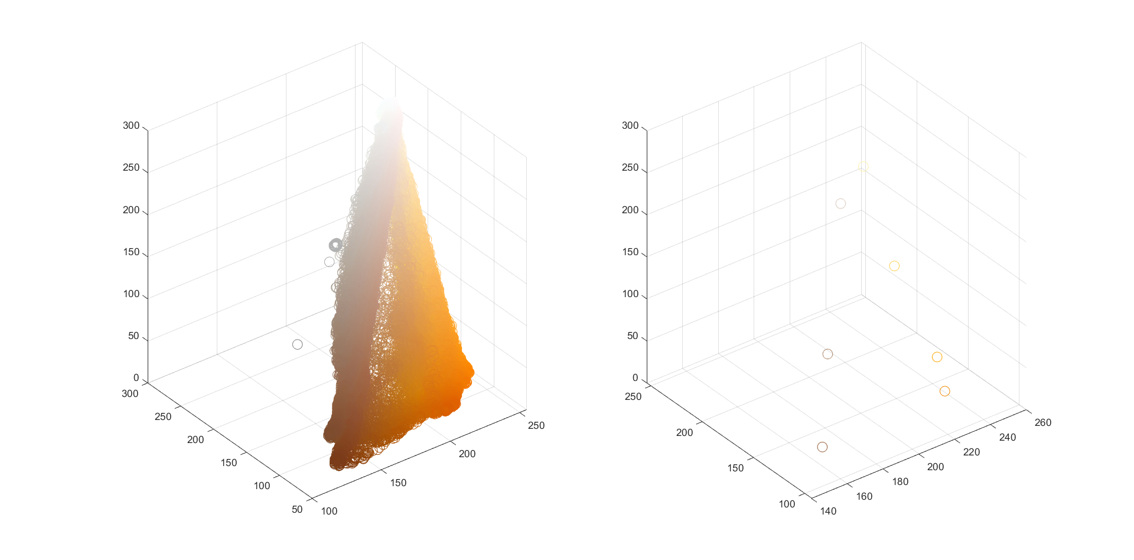

___________________________________________________________________________

**Question 2**: How many iterations L do you typically need to reach convergence, that is the point where no additional iterations will affect the end results?

Answers:

**Test 1 with ‘tiger1.jpg’ (K = 3 & K = 6):**

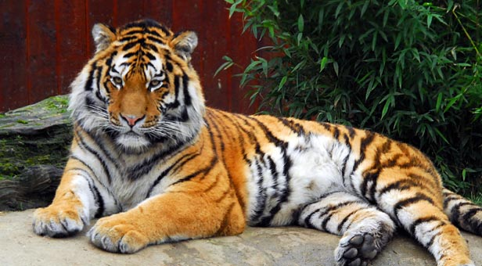

For K = 3 the k-means++ converges at L = 3, difficult to observe differences with additional iterations. Though, there are some small differences along the left paw between L = 3 and L = 20.









For K = 6 the k-means++ starts to converge at L = 3, at least for the color tones (centroids). There is some notable differences in segmentation along the left paw from L = 3 to L = 10 where additional iterations barely yield any difference.









**Test 2 with ‘tiger3.jpg’ (K = 3 & K = 9):**

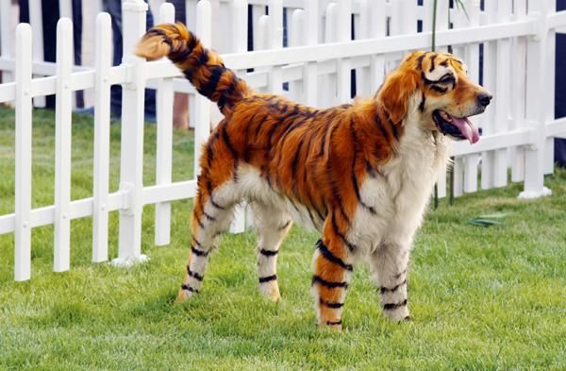

For K = 3, converges at L = 1.





Converges at L = 1. There are some segmentation differences along the back of the dog but there aren’t any major differences.





Conclusion: For the given images the algorithm seems to converge after one to three iterations.m

More iterations are required when blur is applied?

Same with scaling?

___________________________________________________________________________

**Question 3**: What is the minimum value for K that you can use and still get no superpixel that covers parts from both halves of the orange? Illustrate with a figure.

Answers:



___________________________________________________________________________

**Question 4**: What needs to be changed in the parameters to get suitable superpixels for the tiger images as well?

Answers:

There is a lot of variation in the fur of the tigers, blur can help to smooth that out to create larger super pixels.

More complex image => more iterations

___________________________________________________________________________

**Question 5**: How do the results change depending on the bandwidths? What settings did you prefer for the different images? Illustrate with an example image with the parameter that you think are suitable for that image.

Answers:



By increasing the spatial bandwidth, the size of the area in the spatial domain increases. This results in more pixels getting grouped together. A small spatial bandwidth creates many small sections.

Values below 3 yields weird results.





Spatial_bandwidth = 4 gave best

Parameter *color_bandwidth* determines the covariance for the RGB axis. Increasing this yields in grouping similar colors of varying shade. A small value groups less, a larger value groups more. After a certain point changing the *color_bandwidth* doesn’t seem to generate a different result as it seems that the *spatial_bandwidth* limits the segmentation when its set to 8.



Best result:





___________________________________________________________________________

**Question 6**: What kind of similarities and differences do you see between K-means and mean-shift segmentation?

Answers:

Similarities:

* Both algorithms work iteratively. Mean-shift iteratively converges to maxima points where it looks at density of clusters, while k-means converges to minima points where it looks at color values and minimizes the distances between them.
* Both segments the image into different colors, super pixels.

Differences:

* k-means does not care about spatial information. Therefore, similar colored objects that are not connected will can be assigned to the same segmentation, even though they might be on opposite sides of the image. Avoiding this is the main advantage with utilizing mean-shift as it takes spatial position into account.
* Number of clusters needs to be defined for k-means
* The size of the clusters needs to be defined for mean-shift, *spatial_bandwidht* and *color_bandwidth*
* k-means divided into k segments, can’t choose directly amount of segments for mean-shift
* Mean-shift is better at segmenting images that consists of different objects with similar colors.

Other notes:

* Mean-shift is better at generating super pixels in a varying image, e.g. ‘tiger1.jpg’. This is especially apparent for higher k-values when k-means is used.

___________________________________________________________________________

**Question 7**: Does the ideal parameter setting vary depending on the images? If you look at the images, can you see a reason why the ideal settings might differ? Illustrate with an example image with the parameters you prefer for that image.

Answers:

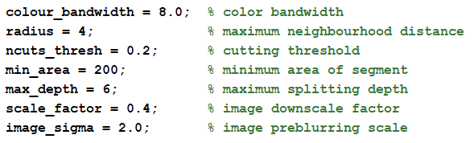



___________________________________________________________________________

**Question 8**: Which parameter(s) was most effective for reducing the subdivision and still result in a satisfactory segmentation?

Answers:

Colour_bandwidth

Max_depth

Radius

Min_area

___________________________________________________________________________

**Question 9**: Why does Normalized Cut prefer cuts of approximately equal size? Does this happen in practice?

Answers:

___________________________________________________________________________

**Question 10**: Did you manage to increase *radius* and how did it affect the results?

Answers:

___________________________________________________________________________

**Question 11**: Does the ideal choice of *alpha* and *sigma* vary a lot between different images? Illustrate with an example image with the parameters you prefer.

Answers:

___________________________________________________________________________

**Question 12**: How much can you lower K until the results get considerably worse?

Answers:

___________________________________________________________________________

**Question 13**: Unlike the earlier method Graph Cut segmentation relies on some input from a user for defining a rectangle. Is the benefit you get of this worth the effort? Motivate!

Answers:

___________________________________________________________________________

**Question 14**: What are the key differences and similarities between the segmentation methods (K-means, Mean-shift, Normalized Cut and energy-based segmentation with Graph Cuts) in this lab? Think carefully!!

Answers:

___________________________________________________________________________